Title
Comparison of Dice Throw Problem and Coin Change Problem Using Dynamic Programming

2. Objective
To compare the Dice Throw Problem and Coin Change Problem using Dynamic Programming and analyze their state transitions, overlapping subproblems, recurrence relations, computational complexity, and scalability.

3. Problem Statement
Dynamic Programming is widely used to solve optimization and counting problems. The Dice Throw Problem determines the number of ways to obtain a target sum using a fixed number of dice, while the Coin Change Problem determines the number of ways to make a target amount using given coin denominations. Both problems exhibit overlapping subproblems and optimal substructure, making Dynamic Programming an efficient solution.

4. Introduction
Dynamic Programming is an algorithmic technique that solves complex problems by breaking them into smaller subproblems and storing intermediate results to avoid repeated calculations.
Two important Dynamic Programming problems are:
- Dice Throw Problem
- Coin Change Problem
Although both problems follow similar principles, they differ in constraints and recurrence relations.

5. Dice Throw Problem
Example
Number of Dice = 2
Faces per Die = 6
Target Sum = 7
Possible Outcomes:
- (1,6)
- (2,5)
- (3,4)
- (4,3)
- (5,2)
- (6,1)
Total Number of Ways = 6
State Definition
DP[d][s]
where:
- d = number of dice used
- s = target sum
Recurrence Relation
DP[d][s] = Σ DP[d−1][s−face]
for all valid face values.

6. Coin Change Problem
Example
Coins = {1, 2, 5}
Target Amount = 5
Possible Combinations:
- 1 + 1 + 1 + 1 + 1
- 1 + 1 + 1 + 2
- 1 + 2 + 2
- 5
Total Number of Ways = 4
State Definition
DP[i][j]
where:
- i = number of coin types considered
- j = current amount
Recurrence Relation
DP[i][j] = DP[i−1][j] + DP[i][j−coin[i]]
PROGRAM :
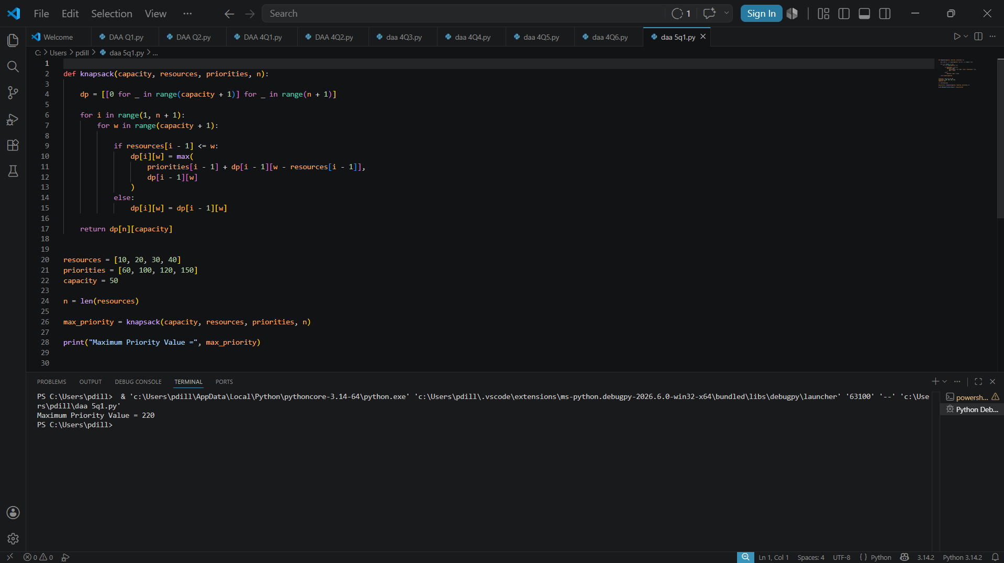

7.Applications
Dice Throw Problem
- Probability analysis
- Gaming systems
- Simulations
Coin Change Problem
- Banking systems
- Financial software
- Resource allocation problems

Conclusion
Both Dice Throw and Coin Change problems demonstrate the effectiveness of Dynamic Programming. Although their constraints and recurrence relations differ, both utilize overlapping subproblems and optimal substructure. Dynamic Programming provides efficient and scalable solutions for these problems and serves as a powerful technique for solving many real-world optimization problems.

References
- Thomas H. Cormen, Introduction to Algorithms.
- Data Structures and Algorithms Using Python.
- Dynamic Programming Concepts and Applications.

